Tsinghua-CUHK Joint Research Center on Media Sciences, Technologies and Systems
Module Division and SSML Specification for Crystal
GD-HK Research Scheme Project
CONFIDENTIAL

This document defines the module divisions of the unified framework for Putonghua and Cantonese Text-to-Speech (TTS) synthesis engine. It also defines the Speech Synthesis Markup Language (SSML) specification for each module, including the function, the SSML interface and the detailed SSML processing procedure for the module.

Document's History
Author | Ver. | Date | Act. | Description
Zhiyong WU | 0.1 | 03/18/2007 | C | Creation of the document
Zhiyong WU | 0.2 | 09/04/2007 | M | Refine the module division  Add say-as specification
Zhiyong WU  Guangqi CAO | 0.3 | 29/04/2007 | M | Refine the namespace specification  Refine the XML specification for each module
Zhiyong WU | 0.4 | 15/05/2007 | M | Refine the module division  Refine the XML specification

Act.: Action = C: Creation, M: Modification, S: Suppression

Table of Contents
Table of Contents I
1. Introduction 1
1.1 Purpose of the Document 1
1.2 GD-HK Project Overview 1
1.3 SSML Overview 2
2. Module Division and Design 3
2.1 General Framework of TTS Engine 3
2.2 Module Division of Crystal 3
3. Name Specification 5
3.1 Name Specification for Source Files 5
3.2 Name Specification for Namespace 6
3.3 Name Specification for Class 8
4. SSML Specification for Each Module 11
4.1 XML and SSML operation 11
4.1.1 Functionality 11
4.1.2 Description 11
4.1.3 Input and output 11
4.1.4 Structure of binary SSML document tree 12
4.2 Pre-processing 13
4.2.1 Functionality 13
4.2.2 Description 13
4.2.3 Input and output 14
4.2.4 Modification of SSML tree 15
4.3 Document structure analysis 16
4.3.1 Functionality 16
4.3.2 Description 16
4.3.3 Problem 17
4.3.4 Input and output 18
4.3.5 Modification of SSML tree 20
4.4 Language conversion 20
4.4.1 Functionality 20
4.4.2 Description 20
4.4.3 Input and output 21
4.4.4 Modification of SSML tree 23
4.5 Text normalization 23
4.5.1 Functionality 23
4.5.2 Description 23
4.5.3 Input and output 25
4.5.4 Modification of SSML tree 26
4.6 Word segmentation 26
4.6.1 Functionality 26
4.6.2 Description 26
4.6.3 Input and output 27
4.6.4 Modification of SSML tree 28
4.7 Prosodic structure generation 29
4.7.1 Functionality 29
4.7.2 Description 29
4.7.3 Input and output 29
4.7.4 Modification of SSML tree 31
4.8 Grapheme-to-phoneme conversion 31
4.8.1 Functionality 31
4.8.2 Description 31
4.8.3 Input and output 32
4.8.4 Modification of SSML tree 34
4.9 Prosody prediction 34
4.9.1 Functionality 34
4.9.2 Description 34
4.9.3 Input and output 35
4.9.4 Modification of SSML tree 37
4.10 Unit selection 38
4.10.1 Functionality 38
4.10.2 Description 38
4.10.3 Input and output 38
4.10.4 Modification of SSML tree 40
4.11 Prosody modification 41
4.11.1 Functionality 41
4.11.2 Description 41
4.11.3 Input and output 41
4.12 Concatenate synthesis 41
4.12.1 Functionality 41
4.12.2 Description 41
4.12.3 Input and output 42
4.13 Speech formatting 42
4.13.1 Functionality 42
4.13.2 Input and output 42
5. Say-as Specification 43
5.1 The interpret-as and format value 43
6. Conclusion and Thanks 45
References 47

Introduction

Purpose of the Document
This document is drafted to define the division and designation of the modules for the unified framework for Putonghua and Cantonese Text-to-Speech (TTS) synthesis engine.
In order to ease the module definition, later intergration and further capability of extension, the Speech Synthesis Markup Language (SSML) [1] specification is introduced to define and describe the input and output interface for each module of the unified framework.
This document describes the detailed information for each module, including:
(1) The functionality;
(2) The SSML based input and output interface;
(3) The detailed processing procedure for programming.

GD-HK Project Overview
The GD-HK project, entiled “Text-to-Audio-Visual-Speech Synthesis in Putonghua and Cantonese for Stationary and Mobile Aplications Development”, is funded by Guangdong-Hong Kong Technology Cooperation Funding Scheme.
The purpose of the GD-HK project is to develop Chinese Text-to-Audio-Visual-Speech (TTAVS) synthesis technologies for Putonghua and Cantonese. The TTAVS synthesis integrates the technologies of (i) Text-to-Speech (TTS) synthesis for synthetic audio speech, with (ii) Text-to-Visual-Speech (TTVS) synthesis for computer animation of a talking head, where the lip movement of the talking head is synchronized with the synthetic audio speech.
We plan to develop both a desktop software version for stationary applications (in the home or office), as well as a mobile (embedded) version for smart-phones, PDAs or the digital home gateway.
Our technologis will support global standards, namely SSML from World Wide Web Consoutium (W3C) [1], the Facial Animation Parameters (FAP) from Motion Pictures Expert Group (MPEG)-4 [5], and also the Speech Application Programming Interface (SAPI) 5 API family from Microsoft cooeperation [6] to facilitate the interoperability in applications development.

SSML Overview
The Speech Synthesis Markup Language (SSML) is developed by the Word Wide Web Consortium (W3C). It is designed to provide a rich, XML-based markup language for controlling and assisting the synthesis procedure of the Text-to-Speech (TTS) engine for web and other applications. The current public released version of SSML is 1.0 [1], which was published on September 7, 2004.
The SSML is an XML-based markup language. The SSML compatible TTS engine will be able to benefit from SSML in terms of easy further extensibility and easy integration with other SSML compatible engines.

Module Division and Design

General Framework of TTS Engine
Generally, a TTS engine contains two main components. One is NLP (natural language processing), and the other is DSP (digital signal processing). The NLP component takes the plain or formatted text as input, proforms the natural language understanding (NLU) procedures, and then outputs the linguistic respresentation of the NLU result. The DSP component takes the linguistic respresentation as input, and generates the speech output.
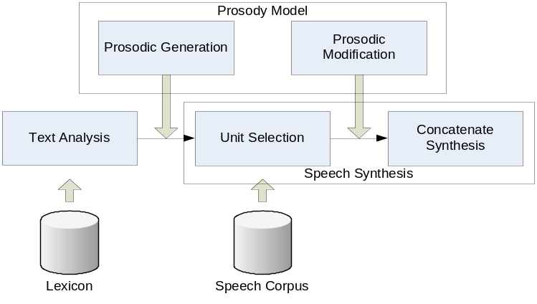
Figure 2-1 The general famework of a TTS engine
Figure 2-1 dipicts the general framework of a typical Text-to-speech (TTS) synthesis engine. The text analysis module takes the functionality of the above NLP component; the prosodic generation module, unit selection module, concatenate synthesis module and the prosodic modification module takes the functionality of the above DSP component. Among all the modules, the text analysis module and the prosodic prediction module are language dependent (language specific); while the other three modules are language independent.

Module Division of Crystal
The proposed TTS engine incudes two separated offline and online parts. The offline part provides the text and speech inventories, statistical rules and results based on the inventories, and finally, the pronunciation lexicion dictionary and the large scale speech corpus, etc. The online part takes the plain or formatted text as input, performs the necessary processing and finally generates the synthetic speech output.
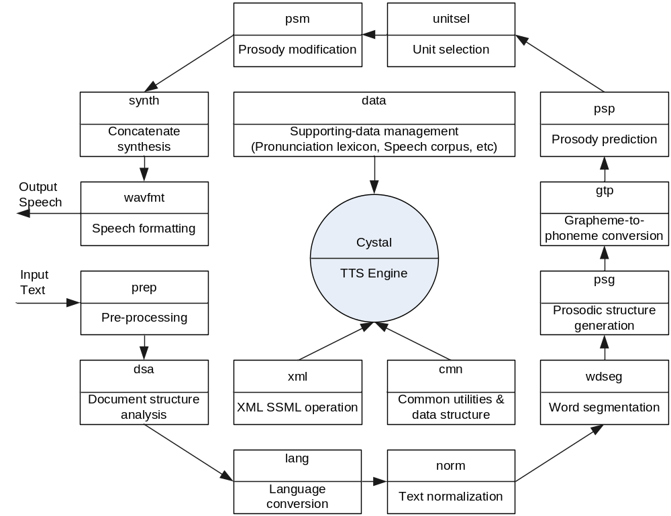
Figure 2-2 The flowchart and module division of the proposed Crystal TTS engine
The flowchart and module division for the online part of the proposed TTS engine is illustrated in Figure 2-2. Every rectangle denotes a module of the proposed TTS engine. The upper part text in each rectangle is the abbreviation of a specific module; the lower text denotes the formal full name of the module.
In the above module specification, the pre-processing, document structure analysis, language conversion, text normalization, word segmentation, prosodic structure generation, and grapheme-to-phoneme conversion modules belong to the NLP component of the TTS engine. The prosody prediction, unit selection, prosody modification, and concatenate synthesis modules belong to the DSP component of the TTS engine.
In order to provide further capability of extension and later integration, the SSML based input and output interface for the above modules should be defined. It should be noted that the pre-processing module must support both plain and SSML formatted text as input; the SSML formatted text can be either well formatted (with well defined SSML tags) or partially formatted (with only partical SSML tags). Besides the pre-processing module, all the other modules can only accept SSML formatted document with well define SSML tag information.

Name Specification

Name Specification for Source Files
The file name of the source files should be very clear and it would be better to indicate the functionality of the related source code. The file name should also be module realted, which means that the module information should be included in the file name to prevent the name confliction between different modules when the files are copied into one directory. The file name should also be extensible for later extensibility and system migration from one platform to another.
To achieve the above purpose, the source file name must obey the following rules.
RULE 1: Name of a source file must start with the module abbreviation and the underline “_”.
RULE 2: Besides module abbreviation, the rest part of the file name should use full English word as far as possible and the underline “_” to connect different English words.
RULE 3: Name of a source file can only be composed of lowercase English character, Arabic digital character, and the underline “_”.
Some appropriate examples are givin in Table 3-1. The abbreviations for each module are summarized in Table 3-1, which can also be found in Figure 2-2.
Table 3-1 Some appropriate examples of the source file name specification
Module | Module abbreviation | Source file name examples
Pre-processing | prep | prep_big52utf16.cpp  prep_gb2utf16.cpp  prep_init.cpp  prep_init.h
Word segmentation | wdseg | wdseg_chinese_name.cpp  wdseg_segmentation.cpp
Unit selection | unitsel | unitsel_calculate_cost.cpp  unitsel_cart_tree.cpp  unitsel_match.cpp
XML SSML operation | xml | xml_parse.cpp  xml_ssml.cpp
Common utilities | cmn | cmn_hash_table.cpp  cmn_string.cpp
Supporting-data management | data | data_init.cpp  data_lexicon.cpp  data_speech_lib.cpp
Document structure analysis | dsa
Language conversion | lang
Text normalization | norm
Prosodic structure generation | psg
Grapheme-to-phoneme conversion | gtp
Prosody prediction | psp
Prosody modification | psm
Concatenate synthesis | synth
Speech formatting | wavfmt

Name Specification for Namespace
To prevent the name confliction of class or other items between different implementations, the namespace must be used for every module implementation. The use of namespace can also help in the organization and displaying in the class view of Microsoft visual studio workspace.
The following rules must be obeyed when specifying the namespace.
RULE 4: The root namespace must be “CST”, which means “Crystal Speech Toolkit”.
RULE 5: The second namespace for common utility modules is specified in Table 3-2.
RULE 6: The second namespace for common TTS engine must be “TTSBase”.
RULE 7: The second namespace for Putonghua TTS engine must be “TTSPutonghua”.
RULE 8: The second namespace for Cantonese TTS engine must be “TTSCantonese”.
RULE 9: The third namespace must start with the capitalized “N”.
RULE 10: The third namespace is module related, and must use the specification in Table 3-3.
Table 3-2 The namespace specification for common utility modules
Module | Namespace
XML SSML operation | NXML
Common utilities | NCommon
Wave formatting | NWave
Supporting-data management | NData
Pronunciation lexicon management | NLexicon
Speech corpus management | NSpeechLib
Table 3-3 The namespace specification for TTS related modules
Module | Namespace
Pre-processing | NPreProcess
Document structure analysis | NDocStruct
Language conversion | NLangConvert
Text normalization | NTextNormalize
Word segmentation | NWordSegment
Prosodic structure generation | NProsodyStruct
Grapheme-to-phoneme conversion | NGTPConvert
Prosody prediction | NProsodyPredict
Prosody modification | NProsodyModify
Unit selection | NUnitSelect
Concatenate synthesis | NSynthesize
A namepace specification example for XML operation is given in . Another namespace specification example is given in Figure 3-4, which represents the unit selection module for Putonghua TTS engine.
Figure 3-3 A namespace specification example for common XML operation module
Figure 3-4 A namespace specification example for unit selection module of Putonghua TTS Engine

Name Specification for Class
When specify the class name, the following rules must be obeyed.
RULE 11: The class name must begin with capitalized “C”.
RULE 12: The class name must use full English words.
RULE 13: The first character of each English word in the class name must be capitalized.
Some examples can be found in Table 3-4.
Table 3-4 The examples of class name specification
Function | Class name specification
Big5 to Unicode (utf16) conversion | CBig5ToUtf16
SSML document manipulation | CSSMLDocument
Unit selection module using CART tree | CUnitSelectCART
Text normalization | CTextNormalization

For more information about coding standard and specification, please refer to the document “GD-HK Coding Standard”.

SSML Specification for Each Module
In the following sections, the detailed description and SSML specification for each module of our proposed TTS engine will be described.

XML and SSML operation

Functionality
The functionalities of XML and related SSML operation are to:
(1) Parse and/or build a well-defined and well-organized XML (SSML) document;
(2) Provide a mechanism to access and operate the elements of the SSML tree.

Description
The basic data structure in proposed TTS engine is SSML document, which is a XML-based binary tree and composed of nodes and pointers. The XML and SSML operation module provides a method for other modules to get access to an SSML document and modify it.
The first functionality of XML operation is to parse and/or build a well-define and well-organized XML (or SSML) document. For example, to build a binary XML (SSML) document tree from an SSML document text file, an SSML document text string, and a PLS (Pronunciation Lexicon Specification) [3] document.
The second functionality of XML operation is to provide a method for other modules to get access and modify an SSML document. With this functionality, the other modules (e.g. Word Segmentation) will be able to control and modify the values of SSML elements, for example, to add, delete and set a node of SSML tree.

Input and output
The input of this module must be a text string, which contains the XML text and is encoded in little-endian UTF-16.
The output of this module is the in memory SSML tree (binary SSML document) encoded in little-endian UTF-16.

Structure of binary SSML document tree
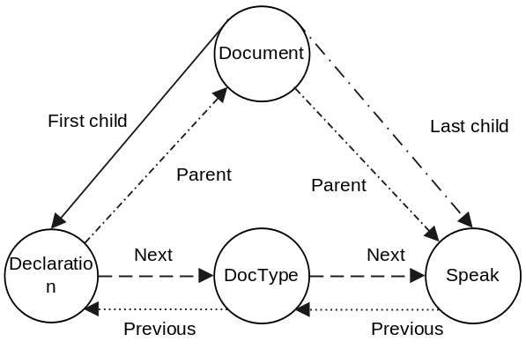
Figure 4-5 The tree structure of the binary SSML document in memory
The in memory SSML document (binary SSML document) is stored in tree structure, as depicted in Figure 4-5. The binary SSML document is composed of nodes and pointers. A node has a value and a series of attributes (including attribute name and related value). The root node of the SSML document tree is <cocument> node. The first child of document is normally <declaration> node. The last child of document is <speak> node. Between <declaration> node and <speak> node, there are normally some other nodes, such as <DocType> node in Figure 4-5. This structure is in correspondence with the SSML [1] specification; an example of the SSML specification is shown in Figure 4-6.
Figure 4-6 An example of the SSML specification to synthesize Putonghua speech from Simplified Chinese characters (i.e. xml:lang=“zh-cmn-Hans”)
The “xml:lang” attribute of <speak> node specifies the main language of the content. The “xml:lang” has two functions, one is to identify the “target language” to synthesize, for example, “zh-cmn” means to synthesize Putonghua speech, while “zh-yue” means to synthesize Cantonese speech. The second function of “xml:lang” is used as the “script” of the written characters, for example, “xml:lang” for “今天天气很好” is “zh-Hans”, which means Simplified Chinese; while “xml:lang” for “明天去動物園” is “zh-Hant”, which means Traditional Chinese.

Pre-processing

Functionality
The functionalities of pre-processing module are as follows:
(1) To parse the SSML tag contained in the original input text;
(2) To convert all the input text into UTF-16 little-endian string;
(3) To generate a complete well-formatted SSML document from the input text.

Description
Pre-processing module is very important for the TTS engine because it provides the input interface for the whole TTS engine. Pre-processing module must be able to process every kind of possible text input, for example, text with well-formatted or partially-formatted SSML tagging, plain text without any SSML tagging, or even text with valid or invalid SSML tagging, and the text with different kinds of encodings, such as GB2313, GBK, GB18030, Big5, UTF-7, UTF-8 or UTF-16, etc.
(1) To perform the character encoding analysis for Big5, GB, UTF-8 or UTF-16, and convert all the input text into UTF-16 little-endian string.
Because all the following processes in subsequent modules are all performed on the UTF-16 little-endian text, encoding conversion must be perform to create the UTF-16 text in the SSML document. For example, all the GB2312 and Big5 text are converted to UTF-16 text. The source encoding information (such as GB2312, Big5, etc) is specified by the user (caller), or retrieved automatically from the XML version-encoding head of the SSML formatted input text (i.e. from the head “<? xml version=‘1.0’ encoding=‘Big5’?>”).
(2) To parse the SSML tag and generate a well-formatted SSML document from input.
If the input text contains the SSML tagging, the pre-processing module must be able to parse these tags and perform corresponding processes. For example, if the intput text contains invalid SSML tag, the module should able to raise the error or ignore it according to user’s preference.
The pre-processing module should provide the interface for the user (caller) to specify whether SSML tagging is supported or not. If SSML tagging is set to be not supported, all the possible SSML tagging in the input should be treated as special symbols or English characters.
If the input text is plain text without any SSML tags, or text with partially-formatted SSML tags, it should be packed by SSML head elements as shown in Figure 4-7. The “xml:lang” attribute of <speaker> element can be “zh-cmn” for Putonghua TTS engine and/or “zh-yue” for Cantonese TTS engine.
It should also be noted that the input string might include special characters which are used in XML specification, such as ‘/’, ‘&’, ‘;’, ‘<’, ‘>’, etc. If these special XML characters in the input text are not related to any SSML tag, they must be replaced with the XML transitions coding at first. For example, the character ‘<’ will be replaced by ‘&lt;’.
Figure 4-7 SSML packing for input text

Input and output
The input text of pre-processing module can be encoded in GB2313, GBK, GB18030, Big5, UTF-7, UTF-8 or UTF-16, etc. The input text can also be plain text, partially or completely SSML formatted text with valid or invalid SSML tagging, etc. The pre-processing module should provide the interface to specify whether SSML tagging is supported or not.
The output of the pre-processing module is a well-formatted binary SSML, in which the text is encoded in little-endian UTF-16.
For example, if the input text is “今天天气很好。同一個筆畫的字。明年会举行2008 Olympic game。”, the output result for Putonghua TTS (xml:lang=“zh-cmn”) is shown in Figure 4-8, while the output result for Cantonese TTS (xml:lang=“zh-yue”) is shown in Figure 4-9.
Figure 4-8 Sample output of pre-processing module for Putonghua TTS engine
Figure 4-9 Sample output of pre-processing module for Cantonese TTS engine

Modification of SSML tree
The SSML document tree after pre-processing is almost the same as that in Figure 4-5 excepting that the <speak> node contains the input text encoded in UTF-16 little-endian.
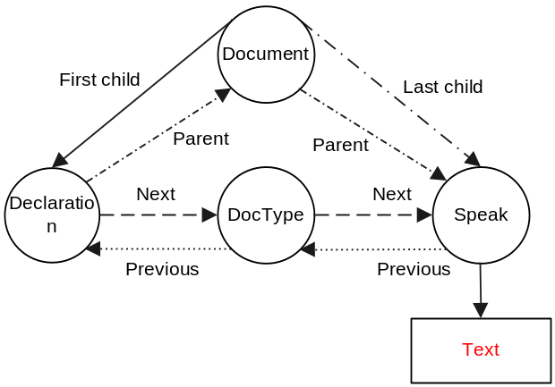
Figure 4-10 SSML document tree created by pre-processing module

Document structure analysis

Functionality
The functionality of the document structure analysis module is:
(1) To segment the input document into paragraphs <p> and sentences <s>;
(2) To detect the language of the content for each piece of characters.

Description
The structure of a document influent the way in which a document should be read. For example, there are common speaking patters associated with paragraphs and sentences.
(1) To segment the input document into paragraphs <p> and sentences <s>.
Punctuations are often used to infer the structure of the document. For example, the “hard return” can be used to generate or infer the paragraphs for SSML document by creating the <p> elements. The full-stop “.” or comma “,” can be used as indicator where the text can be separated into different sentences to create the <s> element in SSML document.
(2) To detect the language (scripts: Simplified Chinese, Traditional Chinese, English, etc) of the content for each piece of characters.
The input text is first grouped into different pieces of characters by encoding information. Each piece will have the same encoding. The language must be then detected for each piece of characters. The language detecting result is the <lang> element. For example, the sentence “我会说普通话也能speak English。” will be converted to “<lang xml:lang=‘zh-Hans’>我会说普通话也能</lang><lang xml:lang=‘en-US’>speak English</lang>”. This means that the first part is written in Simplified Chinese, the second part is written in US English.
It should be noted that when creating the SSML element <s> or <p>, the language detection result should be combined into the attribute “xml:lang” of the <s> or <p> element according to the TTS engine. For example, for Putonghua TTS engine, the final result of the sentence “<lang xml:lang=‘zh-Hans’>我会说普通话也能</lang><lang xml:lang=‘en-US’>speak English</lang>” should be as “<s xml:lang=‘zh-cmn-Hans’>我会说普通话也能<lang xml:lang=‘en-US’>speak English</lang></s>”.
In the above result, the “xml:lang” attribute of <s> element specifies the main language of the whole sentence. This main language information of the sentence is very useful for later processing of TTS engine. For this example, the main language of the sentence is “zh-cmn”, thus the Putonghua TTS engine will be used to perform the “prosodic structure generation” and “prosody generation” for the entire sentence including both Chinese part and the English part. The generated global prosodic information will be then be applied to both Chinese part and English part during “unit selection” and “prosody modification” processing. More specificly, for the English part, the global prosodic information (generated based on the entire sentence) can be used in the “unit selection” module if the English TTS engine supports; otherwise (if the English TTS engine does not support prosodic information in “unit selection”), the global prosodic information will be applied during the “prosody modification” processing.
It also should be noted that segmentation of sentene can sometimes be affected by language detection result. For example, the sentence “他高兴的说：Good Morning!” might be segmented into two sentences with different main sentence language “<s xml:lang=‘zh-cmn-Hans’>他高兴地说：</s>” and “<s xml:lang=‘en-US’>Good Morning!</s>”.

Problem
The main purpose of this module is to get the document structure of the input document. However, it should be noted that segmenting input document into sentences and paragraphs is language dependent especially for the mixed language input. It is also closely correlated to the analysis of some special structrues such as URLs, email, date etc. These special structures involve analysis of symbols, punctuations, digits and even English characters.
For example, the input text “This is number 54,123. 今天是2007.10.1”, the symbol “,” in the number “54,123” can either be the separator in number “54123” or be the real comma. If it is the separator, then the above text can be separated into two sentences. “<s>This is number 54,123.</s>” and “<s>今天是2007.10.1</s>”. If it is the real comma, then the text should have three sentences “<s>This is number 54,<s>”, “<s>123.</s>” and “<s>今天是2007.10.1</s>”.
For better result of the document structure analysis, the processing will have to involve the analysis of symbols or punctuations which might might affect the document structure, such as comma “,” stop “.”, etc. The following paragraphs of this section states the possible solution for this. Detailed information of how to analyze the special constructs will be described in the “text normalization” module.
The detection and analysis of special structures can be performed using the regular expressions. For example, the following regular expression can detect the date with the format “2001.10.01” or “2001-10-01” or “2001/10/01”.
 | (19|20)[0-9][0-9]([- /.])(0[1-9]|1[012])\2(0[1-9]|[12][0-9]|3[01]) | (4-1)
The analysis result of special structures is the <say-as> element, which will be inserted to the SSML document for later interpretation. For example, the above date “2001/10/01” will be coverted to <say-as> element: “<say-as interpret-as="date" format="ymd">2001/10/01</say-as>”. The <say-as> will then be converted to pronounceable text in the “text normalization” module regarding the TTS engine of what language. For example, in Putonghua TTS engine, it will be translated into text “二零零一年十月一日”; while in Engilish TTS engine, it will be translated into text “October the first, two thousand and one”. Detailed supported “interpret-as” and “format” value of <say-as> element can be found in the table in section “5 Say-as Specification”.

Input and output
The input of the document structure module is a well-formatted binary SSML document generated by pre-processing module.
The output of this module is a modified SSML document with document structure information (i.e. <p> and <s> element) together with language information (“xml:lang” attribute in <p> and <s> element, or <lang xml:lang> element) for each sentence, and sometimes the <say-as> element.
Figure 4-11 Sample output of document structure analysis module for Putonghua TTS engine
Figure 4-12 Sample output of document structure analysis module for Cantonese TTS engine

Modification of SSML tree
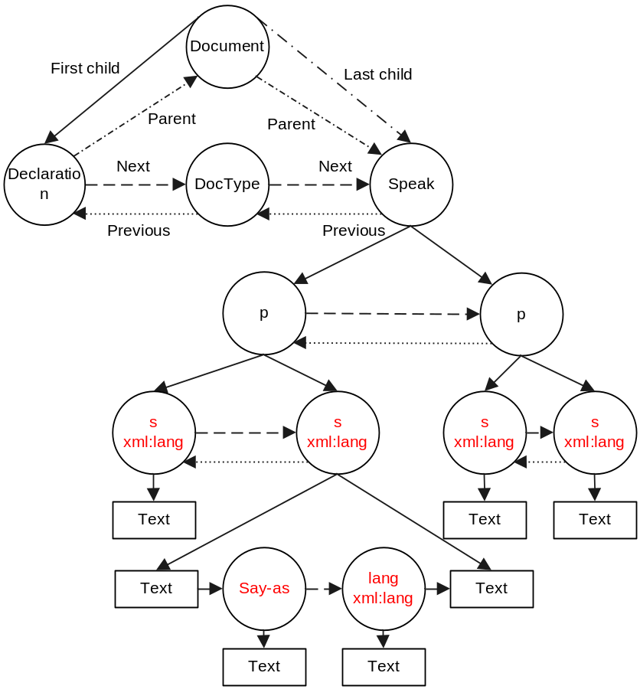
Figure 4-13 SSML document tree modified by document structure analysis module

Language conversion

Functionality
The functionality of language conversion module is to convert the language of the content to the language which current TTS engine supports, for example to perform the conversion between Traditional Chinese and Simplified Chinese characters.

Description
Normally the pronunciation lexcons of a TTS engine can only support limit number of languages. For example, the lexicon of a Putonghua TTS engine might support only Simplified Chinese characters; or the lexicon of a Canonese TTS engine used in Hong Kong S.A.R might support only Traditional Chinese characters.
The “xml:lang” attribute of <p>, <s>, <lang> node specifies the text “scripts” of the content. For example, the “xml:lang” for “今天天气很好” is “zh-Hans”, which means Simplified Chinese; the “xml:lang” for “明天去動物園” is “zh-Hant”, which means Traditional Chinese.
(1) The language conversion module will try to translate (convert) the language of the content as much as possible.
For example, if the TTS engine can support Simplified Chinese only, it will convert all the Traditional Chinese characters with “xml:lang=‘zh-Hant’” into Simplified Chinese, and modify the “xml:lang” to “xml:lang=‘zh-Hans’”. For example, “個體” should be converted to “个体”. It will also convert the English characters with “xml:lang=‘en-US’” to the <say-as> element. For example, “<lang xml:lang=‘en-US’>IBM</lang>” will be converted to “<say-as interpret-as= ‘letters’>IBM</say-as>”.
If the TTS engine can only support Traditional Chinese, it will convert all the Simplified Chinese characters with “xml:lang=‘zh-Hans’” into Traditional Chinese, and modify the “xml:lang” to “xml:lang=‘zh-Hant’”. For example, “中国” should be converted to “中國”. English characters will be converted to <say-as> element too.
If current TTS engine can support Simplified Chinese, Traditional Chinese, and English, no language conversion will be performed.
If current TTS engine can support both Simplified Chinese and Traditional Chinese, all the Chinese characters will be kept unchanged; while English characters will be converted to <say-as> element.
If the language can not be supported or translated by current TTS eingine, it will be left as it is. For example, if current sentence is written in Japanese “<s xml:lang="ja">私は英語と日本語を話すことができる。</s>”, it will be left unchanged.
(2) After language translation, the “xml:lang” of <speak> element can be modified to supporting languages only. At the same time, if the “xml:lang” of <s> element is supported by the TTS engine (covered by <speak>), the “xml:lang” attribute of <s> element can be removed.

Input and output
The input of language translation module is the SSML document with “xml:lang” information.
The output of this module is a modified SSML document where the language of the content is translated as much as possible.
For example, the Putonghua TTS engine which can support Simplified Chinese characters only in pronunciation lexicon, all the Traditional Chinese characters are translated into Simplified Chinese characters, and the English characters are translated to <say-as> element.
Figure 4-14 Sample output of language treanslation module for Putonghua TTS engine
Figure 4-15 Sample output of language treanslation module for Cantonese TTS engine

Modification of SSML tree
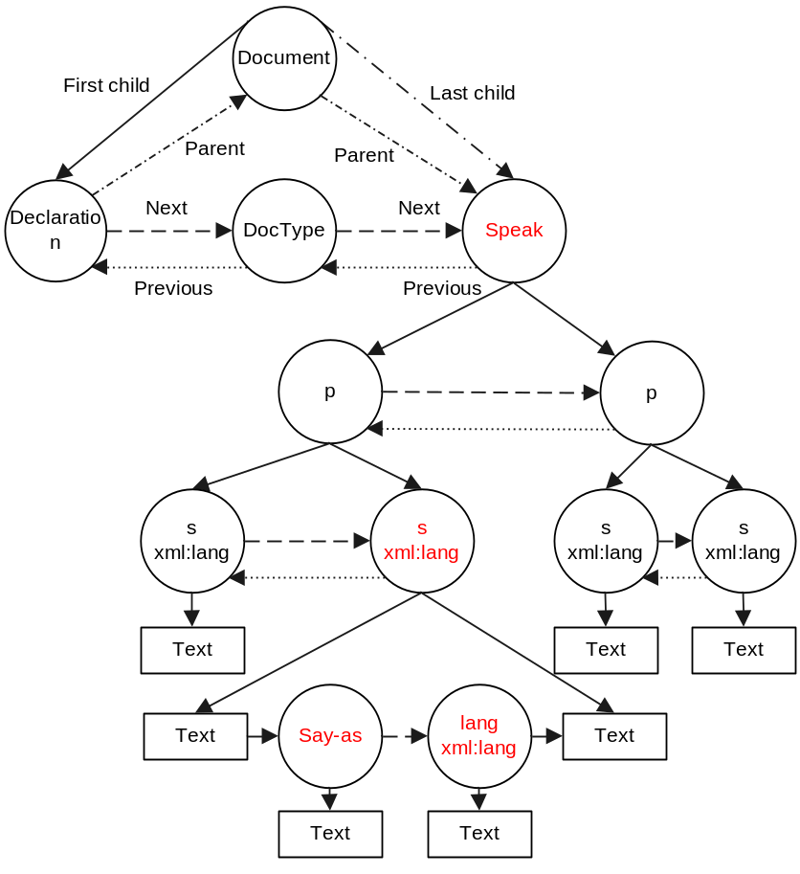
Figure 4-16 SSML document tree modified by language conversion module

Text normalization

Functionality
The functionality of text normatlization module is to convert all written form (orthographic form) of non-Chinese characters (e.g. symbols, punctuations, digit numbers, and English characters) into Chinese characters (pronounceable spoken form).

Description
Input text contains homographs, numbers and abbreviations that all ultimately require expansion into a phonetic representation. Text normalization implements the conversion of the written form into the spoken form. The goal of text normalization is to rewrite non-Chinese characters to Chinese characters, for example, symbols, digits, punctuations, special characters, acronym in English, URL, etc. In one word, text normalization should tell the synthesizer how to read non-Chinese characters.
Sometimes, the punctuations can be ambiguous. For example, the punctuation ‘,’ can be used as comma to separate small sentences, or can be separator in numbers, such as “23,345”. The punctuation ‘-’ can be used in even more situations, such as “-5” means “负五”, “-5°C” means “零下五摄氏度”, “3-5” means “三减去五”, or even in telephone number means “转接” or “传呼”. The punctuation ‘.’ can be decimal in “12.3” reading as “十二点三”or dot in IP address “166.111.58.26” reading as “幺六六点幺幺幺点五八点二六”. The text “1/2” can be read as “一月二日”, “二分之一”, “一除以二”, etc. The text “2:3” can be interpreted as score “二比三” or time “两点三分”. Other examples include “year-month-day” such as “1998/7/20”, “97-7-1”, “1999.10.5” etc.
(1) Detect the special constructs of symbols, punctuations, digits and English characters.
In document structure analysis module, some special constructs such as URL, email, date has been marked as <say-as> element. Text normalization module will convert these elements into Chinese characters. For example, in Putonghua TTS engine, “<say-as interpret-as="date" format="ymd">2001/10/01</say-as>” will be converted to “二零零一年十月一日”.
However, for the symbols which might be context dependent, the text normalization module must have to perform the analysis for these symbols first. For example, in the sentence “比分是2:3”, the text “2:3” must be interpret as score “<say-as interpret-as=‘number’ format=‘score’> 2:3 </say-as>” because the context has the score information “比分”.
After this processing, all the special constructs of symbols, punctuations, digits and English characters must be marked using the <say-as> element. The following process is then performed to convert the <say-as> element into Chinese characters.
(2) Deal with Chinese punctuations and convert to <sub> element if necessary.
For Chinese punctuation, it can be read out or not according to user’s preference. If it is set to read out the punctuations, all the punctuations should be converted to Chinese characters using the <sub> element. For example, the sentence “今天天气很好。” will be converted to “今天天气很好<sub alias=‘句号’>。</sub>” by reading out the “。” as “句号”.
(3) Deal with English string.
For English string, it will be converted to known Chinese alternatives if it can be found in the pronunciation lexicon dictionary. If the English string can not be found in the pronunciation lexicion dictionary, it will be converted to English letters to be read out one letter by one letter.
For example, the sentence “IBM公司CEO” will be converted to “<say-as interpret-as=‘letters’>IBM</say-as>公司<sub alias=‘首席执行官’>CEO</sub>”.
(4) Convert the <say-as> and <sub> element to Chinese characters.
After the above processing, all the symbols, puncturation, digits, and English characters are converted to <say-as> or <sub> element, which should be converted to Chinese characters.
For <sub> element, the text normalization processing should be applied to the “alias” value.
For <say-as> element, it should be converted to pronounceable Chinese characters. It should be noted that the <say-as> generally contains some word information, which can be directly generated when doing the conversion.
For example, in Putonghua TTS engine, the sentence “<s>今天是<say-as interpret-as=‘date’ format=‘ymd’>1999-10-1</say-as></s>”will be converted to “<s>今天是<w>一九九九年</w><w>十月</w><w>一日</w></s>”.
The sentence “<s>比分是<say-as interpret-as=‘number’ format=‘score’> 2:3</say-as></s>” will be converted to “<s>比分是<w>二比三</w></s>”.
The sentence “<say-as interpret-as=‘letters’>IBM</say-ss>公司<sub alias=‘首席执行官’>CEO</sub>” will be converted to “<w>I</w><w>B</w><w>M</w>公司首席执行官”.

Input and output
The input of text normalization is well-formatted SSML document containing <say-as>, <sub> and “xml:lang” information, which is generated by the language conversion module.
The output of text normalization contains Chinese characters, punctuations, and English characters. The Chinese punctuations can be read out or not according to user’s preference. The English characters will be read out one by one in a Chinese TTS engine which contains only 26 English characters in the speech corpus.
Figure 4-17 Sample output of text normalization module for Putonghua TTS engine

Modification of SSML tree
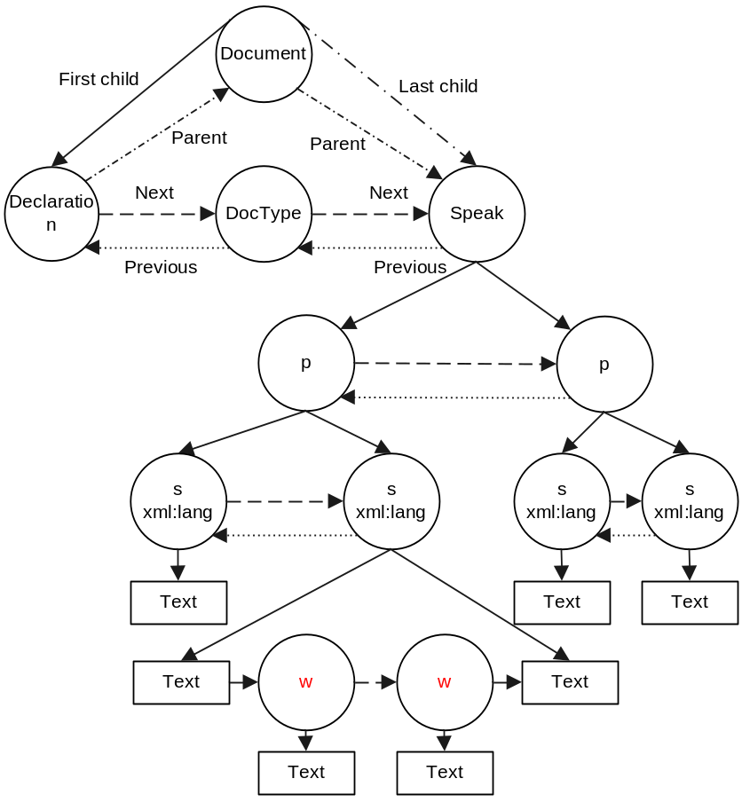
Figure 4-18 SSML document tree modified by text normalization module

Word segmentation

Functionality
The functionality of word segmentation module is
(1) To segment the input sentence into lexicon words according to pronunciation lexicon;
(2) To generate the part-of-speech (POS) information for every Chinese word.

Description
(1) To segment the input sentence into lexicon words according to pronunciation lexicon.
Different from English, there is no boundary (e.g. white space) between different words in Chinese sentence. However, word boundary information is very important for determining the meaning and pronunciation of a word in the sentence. For example, the sentence “南京市长江大桥” has two different meaning and pronunciation because of different word segmentation. (1) It means “the major of Nanjing city, Jiang Daqiao” for word segmentation “<w>南京</w><w>市长</w><w>江大桥</w>”; and the pronunciation is “nan2 jing1 shi4 zhang3 jiang1 da4 qiao2” where the 4th character “长” is pronounced as “zhang3”. (2) It means “the Nanjing Long River Bridge” for word segmentation “<w>南京市</w><w>长江</w><w>大桥</w>”; and the pronunciation is “nan2 jing1 shi4 chang2 jiang1 da4 qiao2” where the 4th character “长” is pronounced as “chang2”..
The word segmentation is generally processed by an automatic procedure based on statistical learning, where large lexicon and rule set is used.
Word segmentation should be performed on all the texts not contained in the <w> element.
(2) To generate the part-of-speech (POS) information for every Chinese word.
Part-of-speech (POS) information is a very important property of Chinese syntax word.
The pronunciation of a Chinese word is related to its part-of-speech. For example, the pronunciation of Chinese character “种 (means plant)” is “zhong4” in word “种花 (means plant the flower)” because its POS is “verb”; while the pronunciation of “种 (means seed)” is “zhong3” in word “花种 (means flower seed)”because its POS is “noun”.
The part-of-speech (POS) information is also useful for word segmentation and prosodic structure generation. For example, in the sentence “他兴奋地说这些花儿太美了”, the POS information for each word is as follows “他(noun)兴奋(adj)地(aux)说(verb)这些(pron)花儿(noun)太(adv)美(adj)了(aux)”. The prosodic strucuture can then be generated by grouping “太美了 adv+adj+aux”, “这些花儿 pron+noun” and “兴奋地说 adj+aux+verb”. The final result of prosodic structure is “他兴奋地说<break strength=’medium’/>这些花儿<break strength=’medium’/>太美了” where “<break strength=’medium’/>” indicates the boundary of prosodic phrase.

Input and output
The input of word segmentation module is a SSML document, where <s> element contains UTF-16 encoded Chinese characters, Chinese punctuations, and English characters. For Chinese characters in sentence (e.g. “伟大的中国人民”), the word boundary should be predicted; the Chinese punctuations (e.g. “逗号”, “。”) are directly marks as a Chinese word; the English characters (e.g. “SINA”) are also directly marked as Chinese words one letter by one letter.
The output of word segmentation is a new SSML document, where the word segmentation information with POS value is added by <w> element.
Figure 4-19 Sample output of word segmentation module for Putonghua TTS engine

Modification of SSML tree
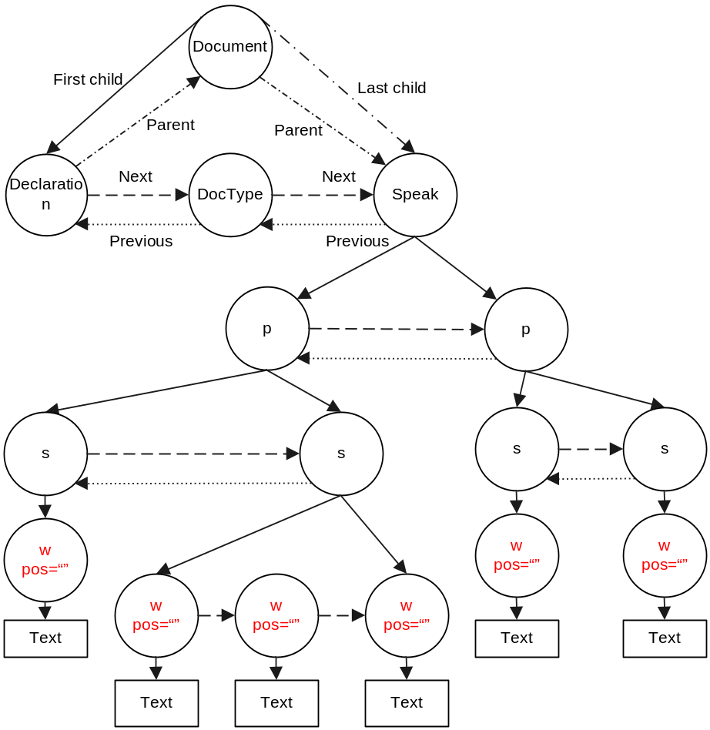
Figure 4-20 SSML document tree modified by word segmentation module

Prosodic structure generation

Functionality
The functionality of prosodic structure generation module is:
(1) To generate the prosodic word boundary;
(2) To generate the prosodic phrase boundary.

Description
During speaking, the speaker always tends to insert appropriate breaks between different words. This is necessary to take the breath, because one can not speak out a very long sentence without breathing.
There are two levels of breaks: the first one is inserted to mark the boundary of prosodic words with a few syllables, which is usually weak (i.e. with short duration); the second one is inserted to mark the boundary of prosodic phrases with several prosodic words, which is usually medium (i.e. with longer duration than prosodic words, but shorter duration than sentence).
The prosodic structure (including prosodic word and prosodic phrase) is very import for generating the synthetic speech with natural prosody and high intelligence.
The prosodic word information can be generated using statictical rules, for example, the “mono-syllable word” (e.g. “了”, “着”, “过”, etc) can be appened to the previous word or the following word.
The prosodic phrase information can be generated using the statictical rules (e.g. C4.5) or maximum entropy model.
The part-of-speech (POS) information might also be useful for predicting the prosodic boundary information.

Input and output
The input of prosodic structure generation module is the SSML document with word segmentation and part-of-speech information.
The output of the module is the modified SSML document with appropriate <break/> element indicating the location of prosodic boundaries.
Figure 4-21 Sample output of prosodic structure generation module

Modification of SSML tree
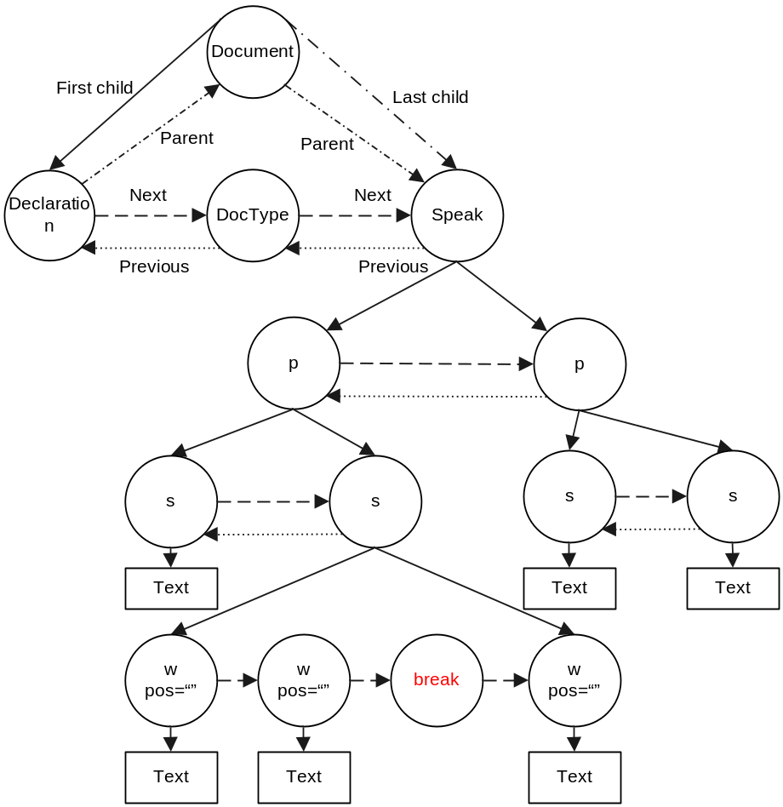
Figure 4-22 SSML document tree modified by prosodic structure generation module

Grapheme-to-phoneme conversion

Functionality
The functionality of grapheme-to-phoneme conversion module is
(1) To get the pronunciation for each lexicon word;
(2) To process the “tone sandhi” for special characters of different character combination.

Description
A TTS engine can know how to read out a word when the pronunciation for this word is specified. The grapheme-to-phonemeconversion module retrieves the pronunciation for each word in the input SSML document and then updates the SSML document by inserting the pronunctiation to it.
The pronunciation of a word is retrieved from a pronunciation lexicon by matching the word and POS information.
Sometime, the tone of a specific character should be changed from its original tone under some specialized character combination.
For example, the tone of characters “一”, “七”, “八”, “不” will change to “tone 2” when these characters appear preceeding to a character with “tone 4”. One example is that “一个” should be pronounced as “yi2 ge4” instead of “yi1 ge4”.
When two characters both with “tone 3” appear in one word, the tone of the first character will change to “tone 2”. For example, “广场” should be pronounced as “guang2 chang3” instead of original “guang3 chang3”. This tone sandhi rule for “continuous tone 3” should be applied inversely from the last character to the first character. For example, “小雨伞” should be pronounced as “xiao3 yu2 san3” instead of “xiao3 yu3 san3”.

Input and output
The input of grapheme-to-phoneme module is the SSML document with word segmentation and part-of-speech information.
The output of the module is the modified SSML document with phoneme information for each word.
Figure 4-23 Sample output of grapheme-to-phoneme conversion module

Modification of SSML tree
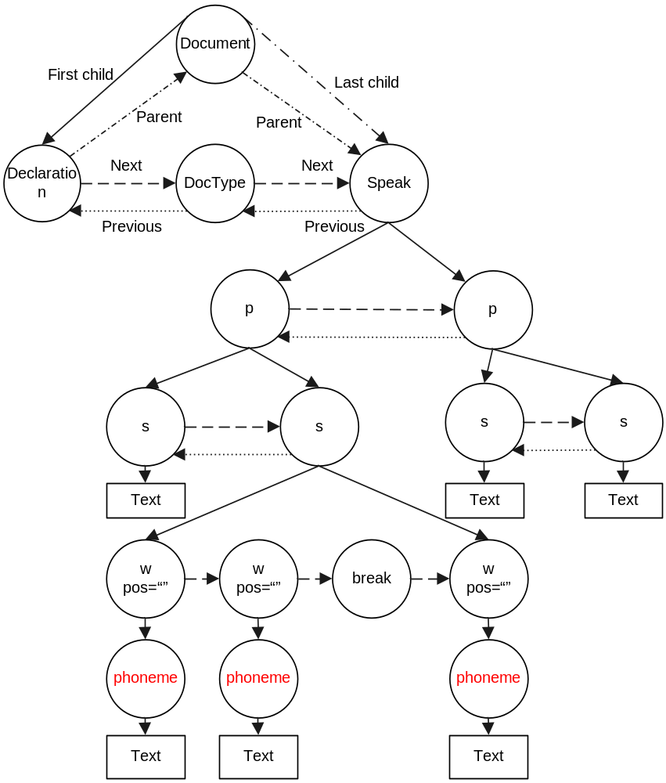
Figure 4-24 SSML document tree modified by grapheme-to-phoneme conversion module

Prosody prediction

Functionality
The functionality of prosody prediction is to predicte the target prosodic information (e.g. pitch, rate, duration, emphasis, etc) for a certain word or syllable (Chinese character).

Description
In the natural speech, the prosodic of the word often changes in order to express the intent, the attitude of a speaker or the expressivity implicated in the text.
The prosodic information is generally related to pitch (F0 contour), speaking rate, samplitude, and duration of the word or syllable.
The prosodic information is also realted to emphasis when the speaker wants to emphasize a specific word or syllable.
In general case, the prosodic information can be applied to any piece of text, ranging from syllable (Chinese character) to paragraph, including syllable, word, prosodic phrase, sentence, paragraph, and even the whole text input.
The processes of the prosodic information prediction include:
(1) To split the word (<w> element in SSML document) into Chinese syllables (<syllable> element in SSML document);
(2) To predict the prosodic information for Chinese syllable or word by adding <prosody> or <emphasis> element. It should be noted that the <prosody> or <emphasis> element can appear at any level except in <phoneme> because <phoneme> element can only contain text (no elements).

Input and output
The input of prosody prediction module is the SSML document with word and pronunciation information.
The output of the module is the modified SSML document with <syllable>, <prosody> or <emphasis> information.
Figure 4-25 Sample output of prosody prediction module

Modification of SSML tree
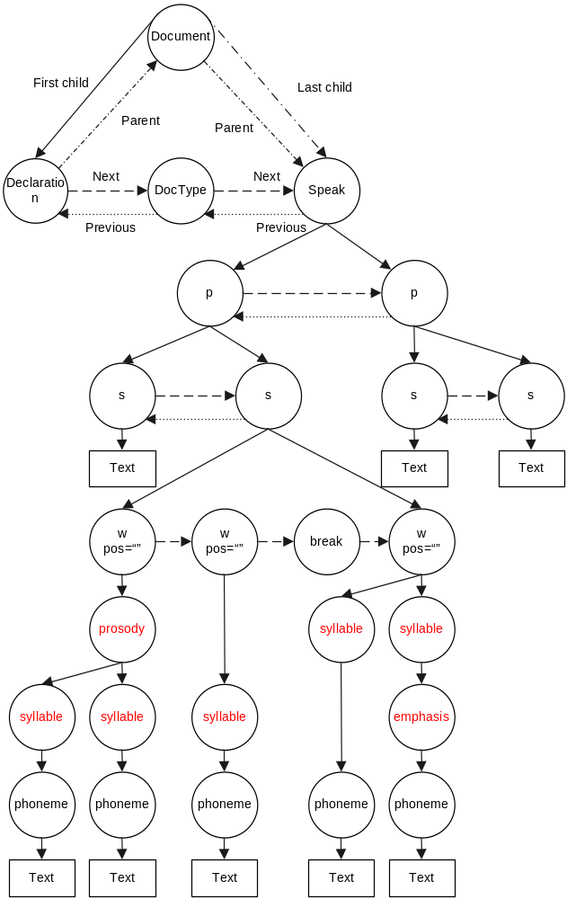
Figure 4-26 SSML document tree modified by prosody prediction module

Unit selection

Functionality
The functionality of unit selection module is to select a speech unit from the speech corpus which is mostly appropriate to synthesize the output speech. Here “appropriate” means both the contextual information and the prosodic information of the selected speech unit are closeset to the target information.

Description
Two kinds of information are used in the unit selection to match the candidate speech unit from the speech corpus against the required target information: contextual information, and prosodic information.
The contextual information comes from the previous modules, such as word segmentation, prosodic structure generation, grapheme-to-phoneme conversion, etc.
The prosodic information comes from the prosodic prediction module, including pitch, duration, emphrasis, rate, amplitude, etc.

Input and output
The input of unit selection module is the SSML document with word, pronunciation and prosody information.
The output of the module is the modified SSML document with the “uid” information of the selected speech unit for each <syllable>.
The format of “uid” is “iCode:index”, where “iCode” is the internal code (integer) for corresponding “pinyin” of current syllable, “index” is the index of the selected speech unit in the speech corpus. For example, “<syllable uid="322:1"><phoneme alphabet="pinyin" ph="qing3">请</phoneme></syllable>”, where “322” is the internal code for pinyin “qing3”, and “1” means the first speech unit with pronunciation “qing3” in speech corpus is selected.
Figure 4-27 Sample output of unit selection module

Modification of SSML tree
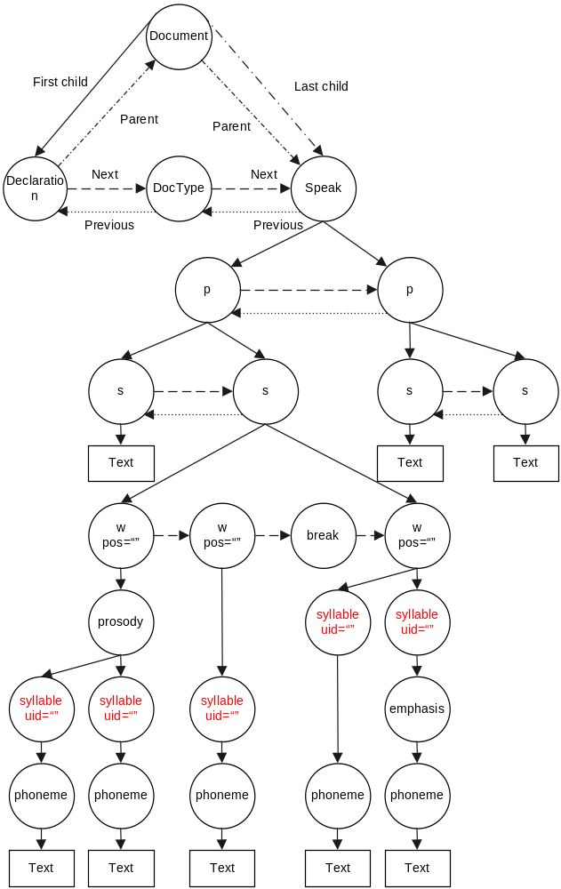
Figure 4-28 SSML document tree modified by unit selection module

Prosody modification

Functionality
The functionality of prosody modification is:
(1) To retrieve the raw wave data of a specific unit from the speech corpus for current syllable;
(2) To perform the prosody modification on the wave data to match the required target prosodic information.

Description
The wave data for a specific syllable is first read out from the speech corpus, where the candidate unit id is specified by the unit selection module.
Prosody modification is then performed on the wave data to match the target prosodic information requied by the prosody generation module. This process involves the digital signal processing (DSP).

Input and output
The input of the prosody modification module is the SSML document with unit selection information ouput by the unit selection module and the target prosodic information output by the prosody generation module.
The output of the prosody modification module is the raw speech wave data (without wave file header) which is stored in the memory.

Concatenate synthesis

Functionality
The functionality of concatenate synthesis module is to concatenate the wave data syllable by syllable to generate the sentence speech.

Description
The raw wave data for every syllable output from the prosody modification module is concatenated together to generate the large wave data for current sentence.
It should be noted that the “boundary smoothing” might be required when concatenating the wave data.

Input and output
The input of the concatenate synthesis module is the raw wave data (without wave file header) stored in the memory which is output from the prosody modification module.
The output of the concatenate synthesis module is the raw speech wave data (without wave file header) for the whole document text which is stored in the memory.

Speech formatting

Functionality
The functionality of speech formatting module is:
(1) To change the format of the synthetic wave data, such as sampling rate, bits per sample;
(2) To output the synthetic speech (raw wave data) to a wave file by adding the head;
(3) To output the synthetic speech to a MP3 file; or
(4) To playback directly using the wave output device.

Input and output
The input the speech formatting module is the synthetic speech (raw wave data) output by the unit concatenation module.

Say-as Specification

The interpret-as and format value
This section defines the possible “interpret-as” and “format” value of the <say-as> element in the SSML specification.
Detailes can be found in the following table.
Table 5-5 Support “interpret-as” and “format” value of <say-as> element
Interpret-as | Format | Interpretation | Examples
letters |  | Interpret the text as English letters | <say-as interpret-as="letters">IBM</say-as>: i bee am
number | cardinal | A cardinal number | <say-as interpret-as="number" format="cardinal">Ⅶ</say-as> : seven  <say-as interpret-as="number" format="cardinal">123< /say-as> : one hundred and twenty three
number | ordinal | An ordinal number | <say-as interpret-as="number" format="ordinal">5</say-as> : fifth
number | telegram | Read digits one by one | <say-as interpret-as="number" format="telegram">123</say-as> : one two three
number | score | A score | The score is <say-as interpret-as="number" format="score">3:1</say-as>：three vs. one
number | fraction | A fraction | To get <say-as interpret-as="number" format="fraction">1/3</say-as>：one third
number | measure | The measurement | <say-as interpret-as="number" format="measure">  cm</say-as>: centimeter
number | telephone | A telephone number | <say-as interpret-as="number" format="telephone">(852) 2609-8248</say-as>
date | ymd | Year-month-day | Today is <say-as interpret-as="date" format="ymd">2003/7/3</say-as>
date | mdy | Month-day-year | Today is <say-as interpret-as="date" format="mdy">7/3/2003</say-as>
date | dmy | Day-month-year | Today is <say-as interpret-as="date" format="dmy">7/3/2003</say-as>
date | ym | Year-month | It was taken place in <say-as interpret-as="date" format="ym">2003/7</say-as>
date | my | Month-year | It was taken place in <say-as interpret-as="date" format="my">7/97</say-as>
date | md | Month-day | Today is <say-as interpret-as="date" format="md">12/1</say-as>
date | dm | Day-month | Today is <say-as interpret-as="date" format="dm">7/3</say-as>
date | y | Year | The <say-as interpret-as="date" format="y">2008</say-as> Olympic Game
time | hms | Hour – minute - second | The meeting will start at <say-as interpret-as="time" format="hms">14:30:09</say-as>
time | hm | Hour-minute | The meeting will start at <say-as interpret-as="time" format="hm">14:30</say-as>
duration | hms | Hour – minute - second | The record is <say-as interpret-as="duration" format="hms">14:30:09</say-as>
 | msms | Minute – second - millsecond | The record is<say-as interpret-as="duration" format="msms">14'30"12</say-as>
 | sms | Second - millsecond | The record is<say-as interpret-as="duration" format="sms">14"30</say-as>
name |  | The entity name | <say-as interpret-as="name">Michael</say-as>
math |  | Math expression | The expression is <say-as interpret-as="math">a+486-1014-30 2003/12/1*(-10291)</say-as>
net | email | Email address | <say-as interpret-as="net" format="email">abc@xyz.com</say-as>
net | uri  url | URL address | <say-as interpret-as="net" format="uri"> http://www.cuhk.edu.hk</say-as>
net | ip | IP address | <say-as interpret-as="net" format="ip"> 166.111.250.45</say-as>

Conclusion and Thanks
This document defines the module divisions of the unified framework for Putonghua and Cantonese Text-to-Speech (TTS) synthesis engine. It also defines the Speech Synthesis Markup Language (SSML) specification for each module, including the function, the SSML interface and the detailed SSML processing procedure for the module.
I would like to express my special thanks to Dr. Dezhi Huang. This document is drafted based on his first draft prepared for Human Computer Speech Interaction (HCSI) laboratory, Tsinghua University and France Telecom.

References
- [SSML]
Speech Synthesis Markup Language (SSML) version 1.0. Daniel B., et al, editor. World Wide Web Consutium, September 7, 2004.
This version of the SSML Recommendation is
http://www.w3.org/TR/2004/REC-speech-synthesis-20040907/.
The latest version of the SSML is available at
http://www.w3.org/TR/speech-synthesis/.
- [REQS]
Speech Synthesis Markup Requirements for Voice Markup Languages. Hunt A., editor. World Wide Web Consortium, 23 December 1999.
This document is a work in progress.
This version of the Synthesis Requirements is
http://www.w3.org/TR/1999/WD-voice-tts-reqs-19991223/.
The latest version of the Synthesis Requirements is available at
http://www.w3.org/TR/voice-tts-reqs/.
- [PLS]
Pronunciation Lexicon Specification (PLS) version 1.0. Paul B., editor. World Wide Web Consortium, 31 January 2006.
This document is a working draft.
The current version of PLS is available at
http://www.w3.org/TR/2006/WD-pronunciation-lexicon-20060131/.
The latest version of PLS is available at
http://www.w3.org/TR/pronunciation-lexicon/.
- [Say-as]
SSML 1.0 say-as attribute values. Daniel B., Paul B, editor. World Wide Web Consortium, 26 May 2005.
This document is a working group note.
The current version of <say-as> note is available at
http://www.w3.org/TR/2005/NOTE-ssml-sayas-20050526.
The latest version of <say-as> note is available at
http://www.w3.org/TR/ssml-sayas.
- [FAP]
Motion Pictures Expert Group, ISO/IEC 14496-2: 1999/Amd. 1:2000(E). International Standard, Information Technology – Coding of Audio-Visual Objects. Part 2: Visual; Amendment 1: Visual Extensions.
- [SAPI]
The Speech Application Programming Interface. Microsoft coorperation.
The SAP 5 API family is avaliable at:
http://www.microsoft.com/speech/download/sdk51/

